
9, 13 and 16 week programmes

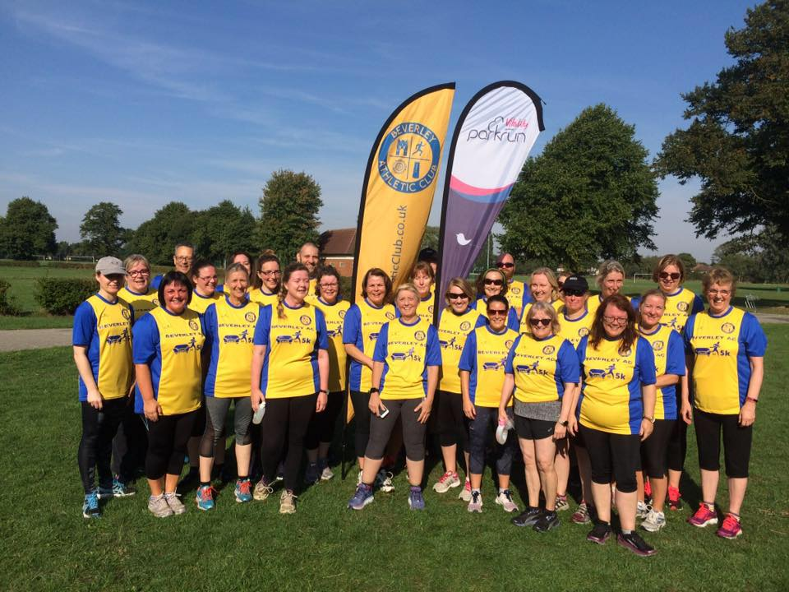

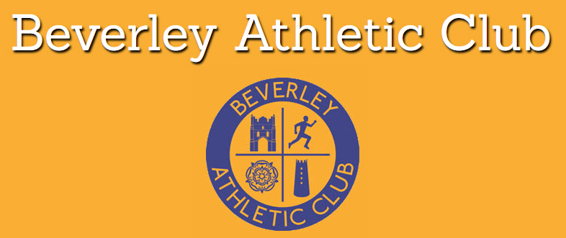

Welcome to your training programmes!

You’re probably thinking…

What on earth have I signed up for?
How hard will it be?
Will I get through it?

In answer to your questions, you’ve signed up for something positive which will make you feel immensely proud at the end. You will amaze yourself at what you can achieve and in embarking on this journey, your body and mind will thank you for it! It will be hard for some people at different points in the programme but you have lots of people to support and help you to achieve your goal and once you signed on you can remain in the group until you do your 5K. This is not a one off but an on-going programme to help you run.

However, we’re not going to make it sound easy, you’ll have days where you just want to stay inside because it’s raining or you’re feeling tired or the kids are ‘doing your head in!’ but this is when you have to remind yourself of why you started and focus on your own personal goal.

But don’t worry! We will be here to support you and give you guidance. We will give you advice on a range of topics, from what shoes to wear to breathing techniques, to overcoming those pesky negative thoughts.

The photograph on the previous page is from the first cohort who all ran their 5K in September 2018.

Contact: secretarybeverleyac@gmail.com.

What are the benefits of this running lark?

Why should I bother with this exercising malarkey?
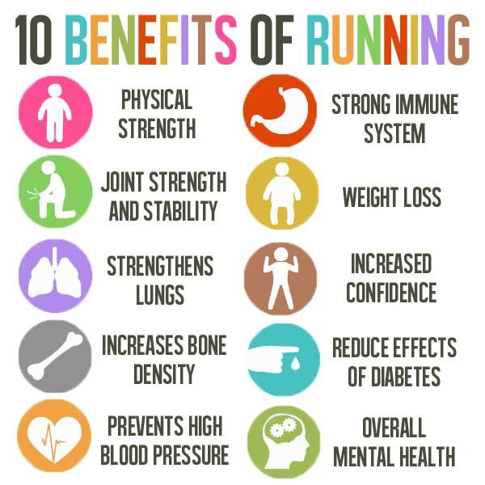

But most importantly it is about you having more control over your fitness and energy.

Fuelling for running; why is it so important?

The food you eat before you exercise really does affect the quality of your athletic performance.
It prevents low blood sugar levels and keeps you from feeling hungry.
A balance of carbohydrates, proteins, fats, minerals, vitamins, and water will give your body what it needs for peak performance.
Fuelling correctly can affect your body’s ability to burn fat and calories, which may be important depending on what your fitness goals are.
Eating regular meals and snacks is vital, as skipping meals will hurt your performance.
Dehydration can alter the function of our most important organs such as the brain, the heart and the muscles themselves.

Food tips for fuelling for running:

Over the next few weeks your body is going to go through many physical changes. These changes need to be supported by a healthy, balanced diet, not starving your body of what it needs.
But this doesn’t mean that you need to give up on your favourite foods!

The main things to consider are:
Eat little and often
Eat when you’re hungry

Don’t save up your calories for one big meal. By eating at the correct times, you minimise the risk of triggering your body’s “starvation protection mechanism” which protects fat supplies. Frequent eating encourages the body to burn fat instead of muscle tissue. So eating little and often means your body isn’t scared to burn off the food because it knows that its next meal isn’t too far away.

If this is the first time you’ve run, or even just started doing more training than you would normally, you might notice a difference in the amount of food/sleep that you need. For the distance we’ll be doing, you may not notice a massive difference, but it could be quite a shock for your body.

Try to eat proper foods that aren’t too processed, instead, eat meats, vegetables, fruit, bread, foods that are low in sugar and will give you the energy that you need (we would advise you stay away from restrictive diets).

Fuelling pre and post-run

Before you run:

Try to avoid eating 2 hours before you run in the best hope to not get a stitch
For the distance that we will be running, you don’t need to worry too much about what you eat in those two hours, and you definitely don’t need to load up on carbs before.
The last time you eat before you run, try to have a glass of water alongside to keep you hydrated.

After you run…

Your body replaces glycogen stores in your muscle within the first few hours post-exercise, so it’s important to eat carbohydrates AND some protein
Try to eat a snack that contains carbohydrates (such as a yogurt or half a sandwich) within 30 minutes following your workout as this will help your body recover quickly.
Fluids: Calorie-containing drinks (such as milk or juice) can replace water and glucose. Milk will also provide protein to help rebuild and repair muscle.
If possible, you should eat a larger meal that’s high in carbohydrates and has some protein within the next 2-3 hours to replace muscle glycogen stores that were used up during exercise. This will help prepare you for the next time you exercise.

Post exercise it’s important that you:

- Rehydrate: Water content (fluid: milk, water)
- Replenish: Muscle glycogen (carbohydrate)
- Repair: Damaged proteins (protein)





Motivation is key…

How to keep yourself motivated:

- Think about the long term goal
- Be social and run with others
- Join the C2-5k Facebook group and join in
- Set a goal to work towards
- Reward yourself
- Vary the running surfaces from road to cross country- it makes it more interesting

It might be worth (before you start any training) filling in these boxes. You only have to write a few words, but looking over these will help you to remind yourself why you started…

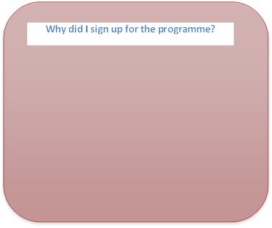
The importance of strength and conditioning when running:
What do I want to get from the programme/achieve at the end?
What will be my motivation?

What do I think the hardest part will be and how will I move past this?

As you embark on this journey it is very likely that you are going to be asking things of your body which you have not asked of it for some time…therefore, it is likely that it might react unkindly to your request!

As a way of trying to mitigate against your body’s protestations, we will introduce an element of strength and conditioning as part of the sessions.

This will include some balance work, co-ordination and control and will hopefully help you become more aware of what it is you are asking of your body when you run.

By the end of the programme you should be able to feel your glutes, hamstrings and calves and know what part they play when running.

None of the strength work we do will involve weights, we will be working on strengthening through balance and resistance.

Running Drills:

These will play a part in each session too as they play their part in injury prevention, warm up and promoting good running form.

Good running form in turn will promote better running efficiency, which should mean you can run further at less effort (if you so choose!)

The running drills we will be focussing on:

- Anklings (aka Irish Dancing!)
- A-skip (aka Angry Skipping)
- Hamstring Runs (aka The Ministry of Silly Runs!)

Trust us…we know what we’re doing

Different types of stretches to try:

Before you stretch!
Make sure your muscles are warmed up before you stretch. Try to avoid stretching first thing in the morning, it could cause injury.
Ease into each stretch, don’t bounce/force it.

Hold each for 15-20 seconds.

Groin stretch
Sit down with the soles of the feet together. Apply force from
The elbows onto the knees until a stretch is felt in the groin.

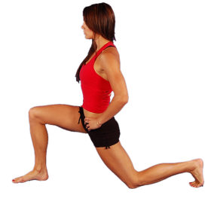
Hip flexor stretch
Lunge forward with your hands places on the knee. Try to
push your hips forward and hold. Repeat on other side.

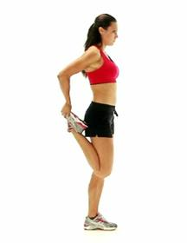
Standing quad stretch
Hold your ankle/foot behind you, resting on a wall. Straighten
your hip by moving the knee back ward and hold the stretch.
Repeat on other leg.

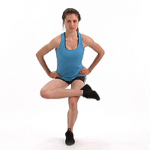
Channel four stretch
Place your ankle on the opposite legs knee and sit down
into it, keep your back up straight. Repeat on both legs.

Calf (drop down off the kerb)

Drop your heel down slightly off the kerb. Bend the leg on
The kerb and drop slowly until you feel a stretch.

Cross-leg hamstring stretch
Cross one leg over the other whilst standing. Slowly lower
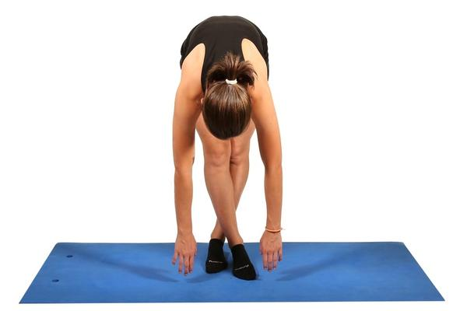
your upper body so that you are bending at the waist.
Repeat on both sides.

Upper body stretch
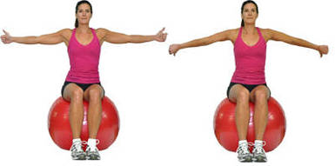
Hold your arms out pointing your thumbs up and push
your arms back slightly. Do the same but with your
thumbs up.

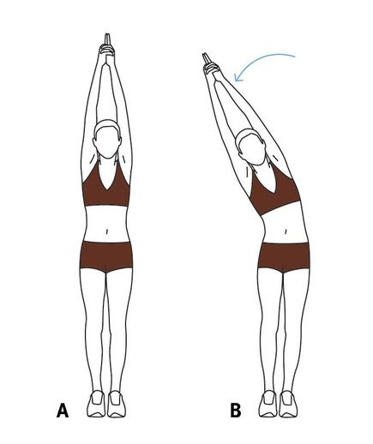
Full body stretch
Stand feet together and arms straight overhead. Keep your hands together and fingers extended. Breathe in as you reach upwards, breathe out as you bend.

