
Introducing
The Beverley ‘Couch to 5k’ Programme



Wednesday
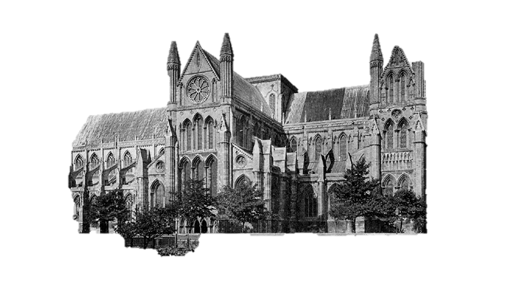
16 May 2018
Meeting at Beverley Leisure Centre 6.45pm

15 week course run by UKA qualified coach to help newcomers to running to achieve the goal of a 5 kilometre run.

Cost £15 with a free T shirt and £15 discount on your first year’s club membership fee.

ingate at
10.

